Exercise balls are a great tool that are used by occupational therapists and can be a great item to have at home to work on a variety of skills such as core strength, postural stability, vestibular processing, and regulation. Exercise balls are available for purchase at a variety of places such as sporting goods stores and online. They come in a variety of sizes and colours dependent on preference and the age/height of your child. It is very important that your child is always supervised by an adult while using a therapy ball for safety and to avoid injury.
Below are 8 fun ways to utilize an exercise ball:
- Prone position on Ball
Have your child positioned on their stomach on the ball as you roll them back and forth. This can help provide them with sensory input to improve regulation and vestibular processing. You can also roll your child forwards and have them hold themselves up on their arms while playing with a toy or completing a puzzle. This is great for increasing your child’s strength and providing them with proprioceptive input which can improve body awareness. As this can be a novel experience for your child, you can start with short periods of time and increase as your child becomes more comfortable and tolerant of the position.
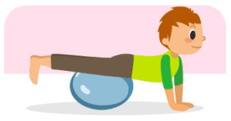
- Supine Position on Ball
Position your child on their backs on the ball. You then can roll them back and forth on the ball while stabilizing them at their hips to provide them with vestibular input. You can also have them reach upside down for game or puzzle pieces and sit up to increase their core strength! When completing the sit-ups be sure your child’s feet are stabilized on the floor or resting on your legs for support.
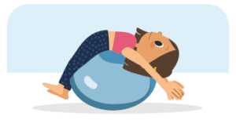
- Roll the Ball Up a Wall
Have your child stand with their feet hip width apart while facing a wall. Place the therapy ball against the wall at chest height and have your child place their hands on the ball while applying pressure. They then have to walk the ball up and down the wall using their hands which helps improve strength/stability, motor planning, and coordination!
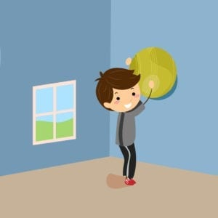
- Sitting Upright on the Ball
Sit your child on the ball while supporting them at the hips or thighs. You can have them reach in all different directions for toys, game pieces, or puzzle pieces to increase postural stability and core strength! Be sure to cue your child to sit up straight!
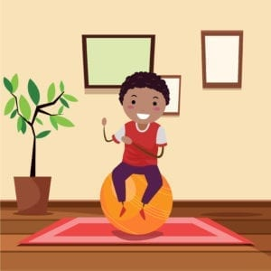
- Rainbow Pass
The Rainbow Pass is a more complex task that takes a lot of strength and coordination. Have your child start with the ball in their hands above their head. Then have the child lift the ball over their head while lifting their feet to the ball. The child will then place the ball in their feet and bring the ball down to the floor with their feet and then back up to pass to their hands. They will then repeat these steps, passing the ball between their hands and feet creating a “rainbow” shape.
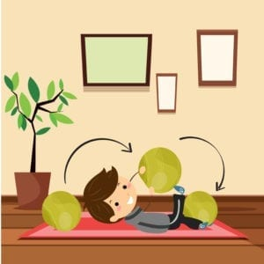
- Kick the ball
You can target your child’s gross motor skills by playing “soccer” with the therapy ball. Have your child kick the ball into a goal or you can also have the child pass the ball back and forth to a peer to promote reciprocal play skills!
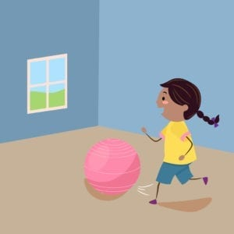
- Ball Rolling
Have your child lay on their stomach on the floor with their head facing to one side. Then place the ball on their back and provide some pressure on the ball as you roll the ball over your child’s body. Providing deep pressure can help calm your child’s body down and improve regulation.
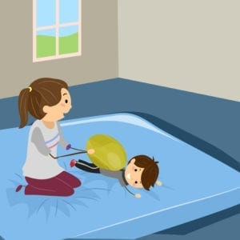
- Play Hot Lava
If you have a large, enclosed trampoline at home, you can place the exercise ball inside the trampoline and have your child try to run around the trampoline without touching the ball (“the hot lava”). This takes coordination, balance, and endurance!
A therapy ball can be a great tool to use at home to help increase your child’s core strength, postural stability, and sensory processing. This tool is also used frequently by occupational therapy sessions to increase a variety of skills. Contact Chicago Occupational Therapy or call (773) 980-0300 to learn more about our services and how we can help your child flourish and grow.

